Octagonal Pyramid
# Source: AI Source: Provided by: [Data Path: Persons Table -> ID Column: 1, Name_En Column: Motasem Essam] -> From: [ChatGPT] on [7/25/2026]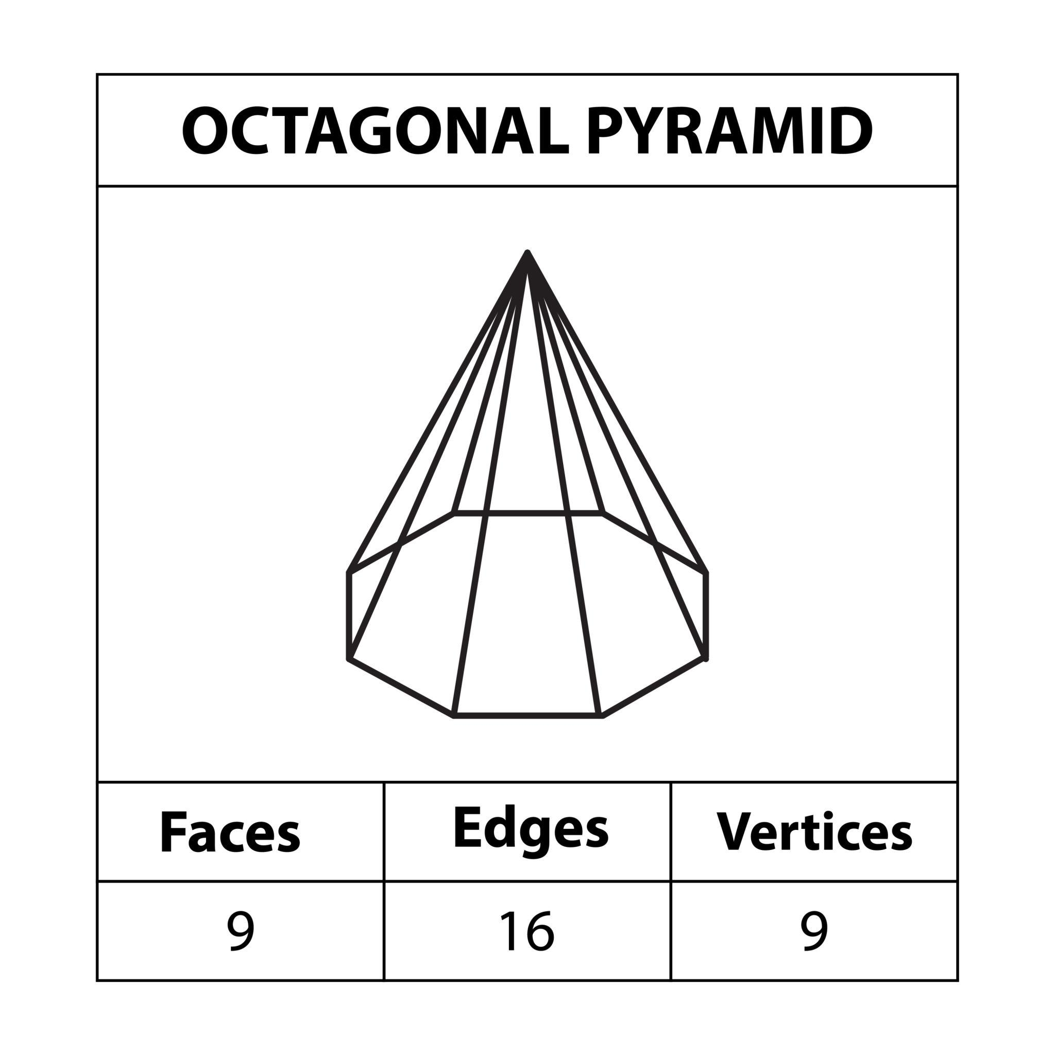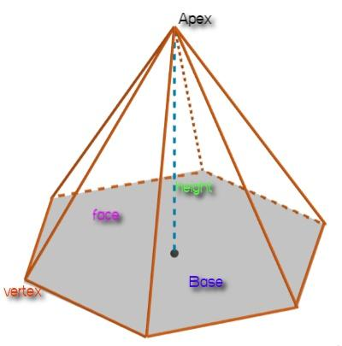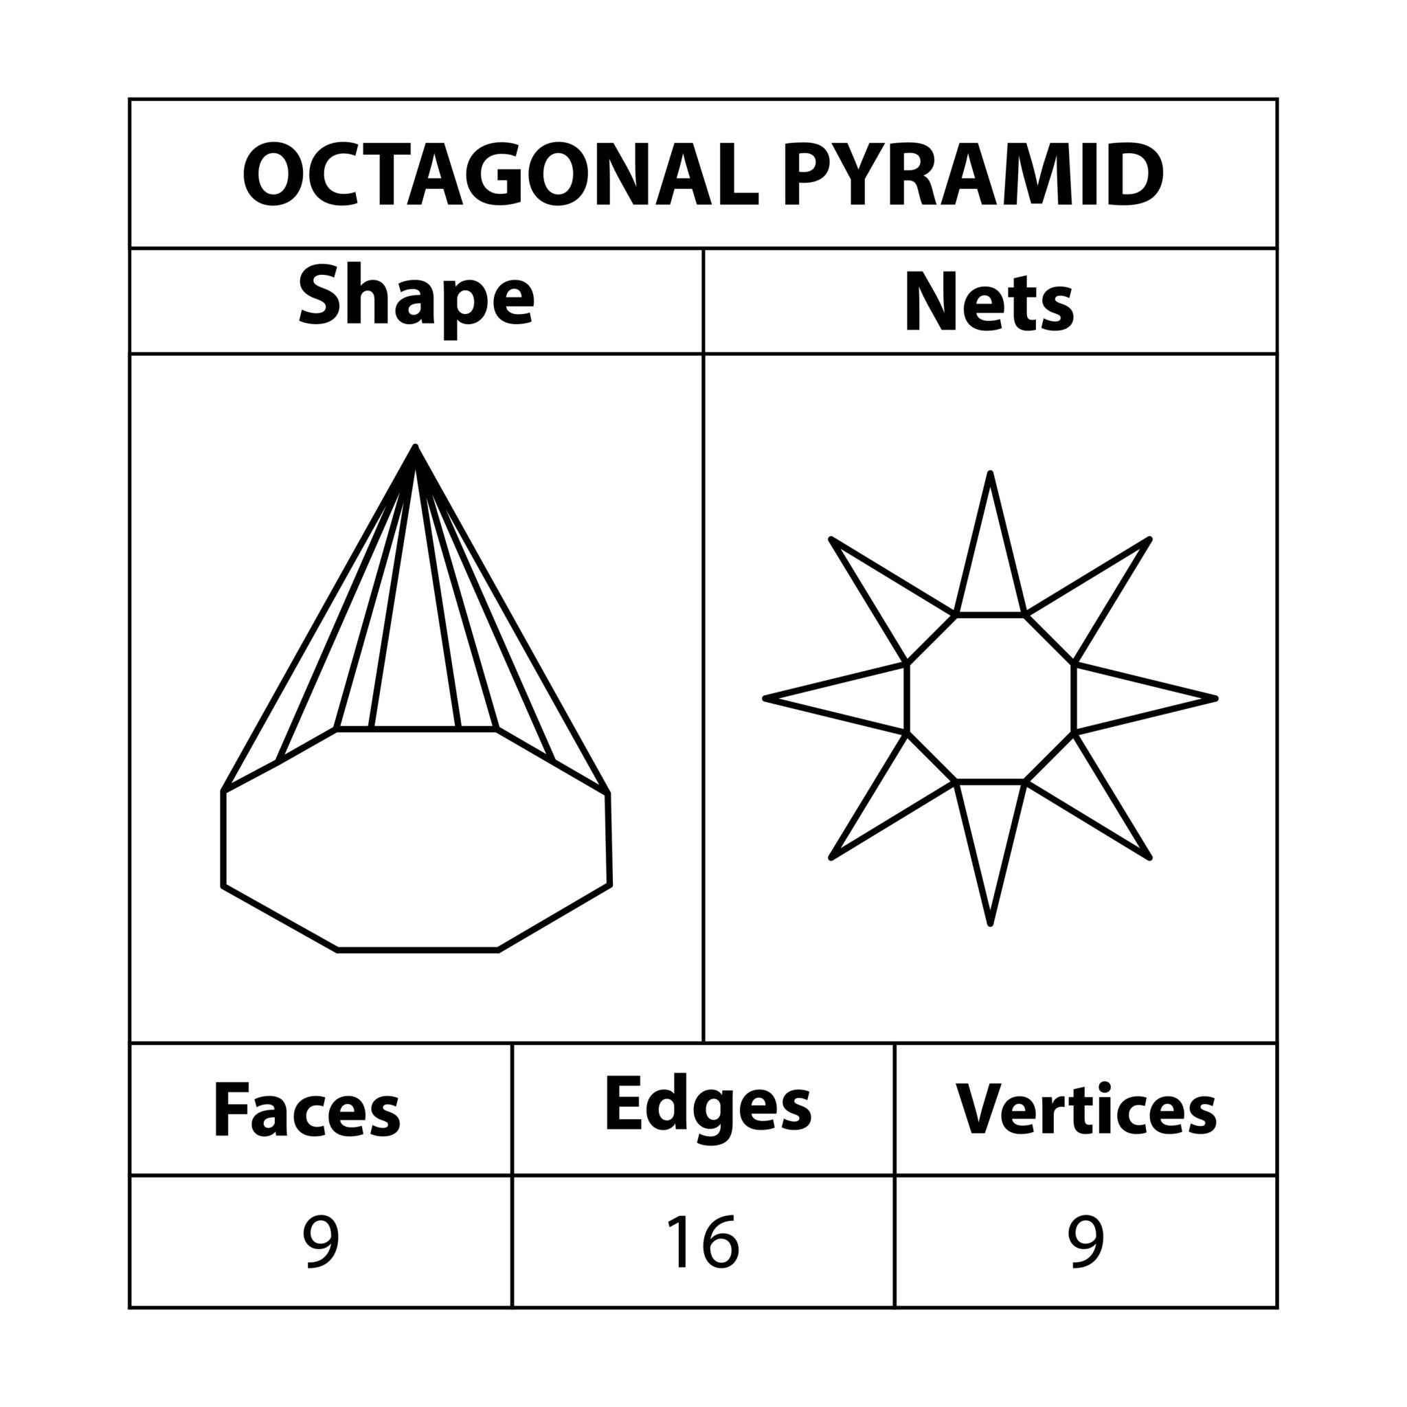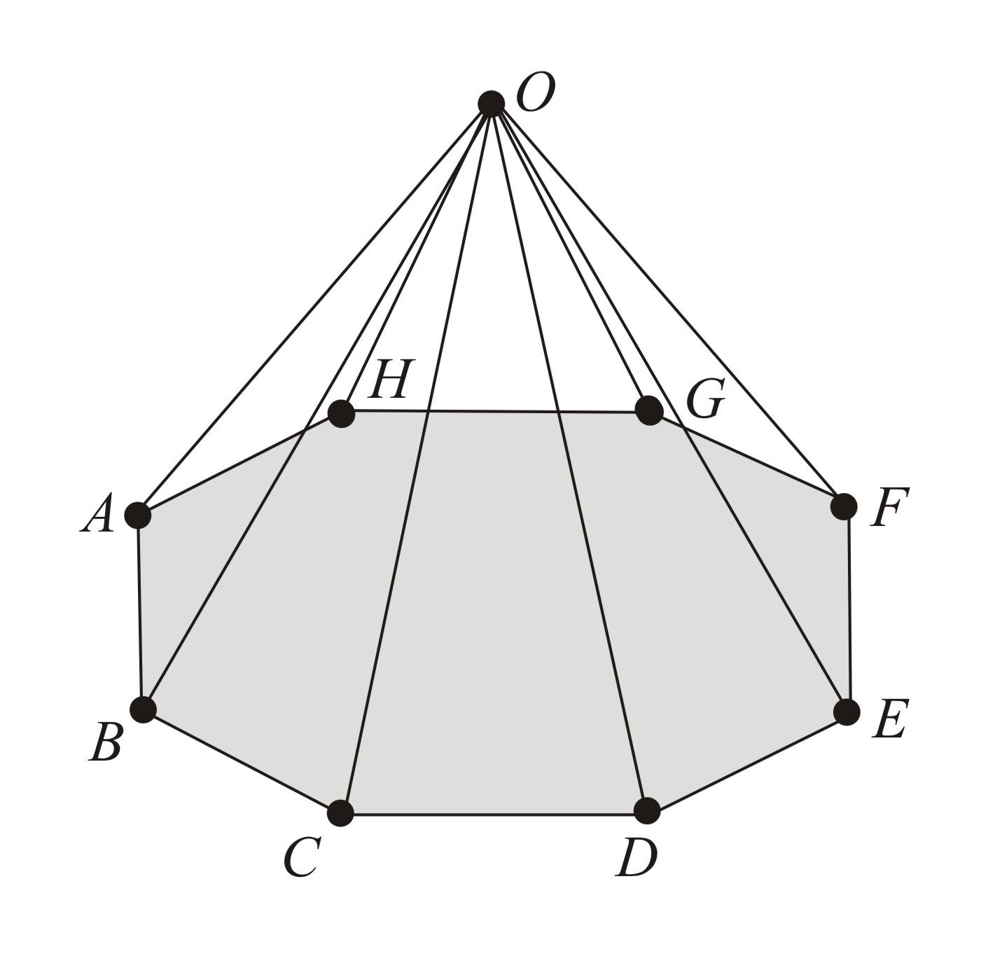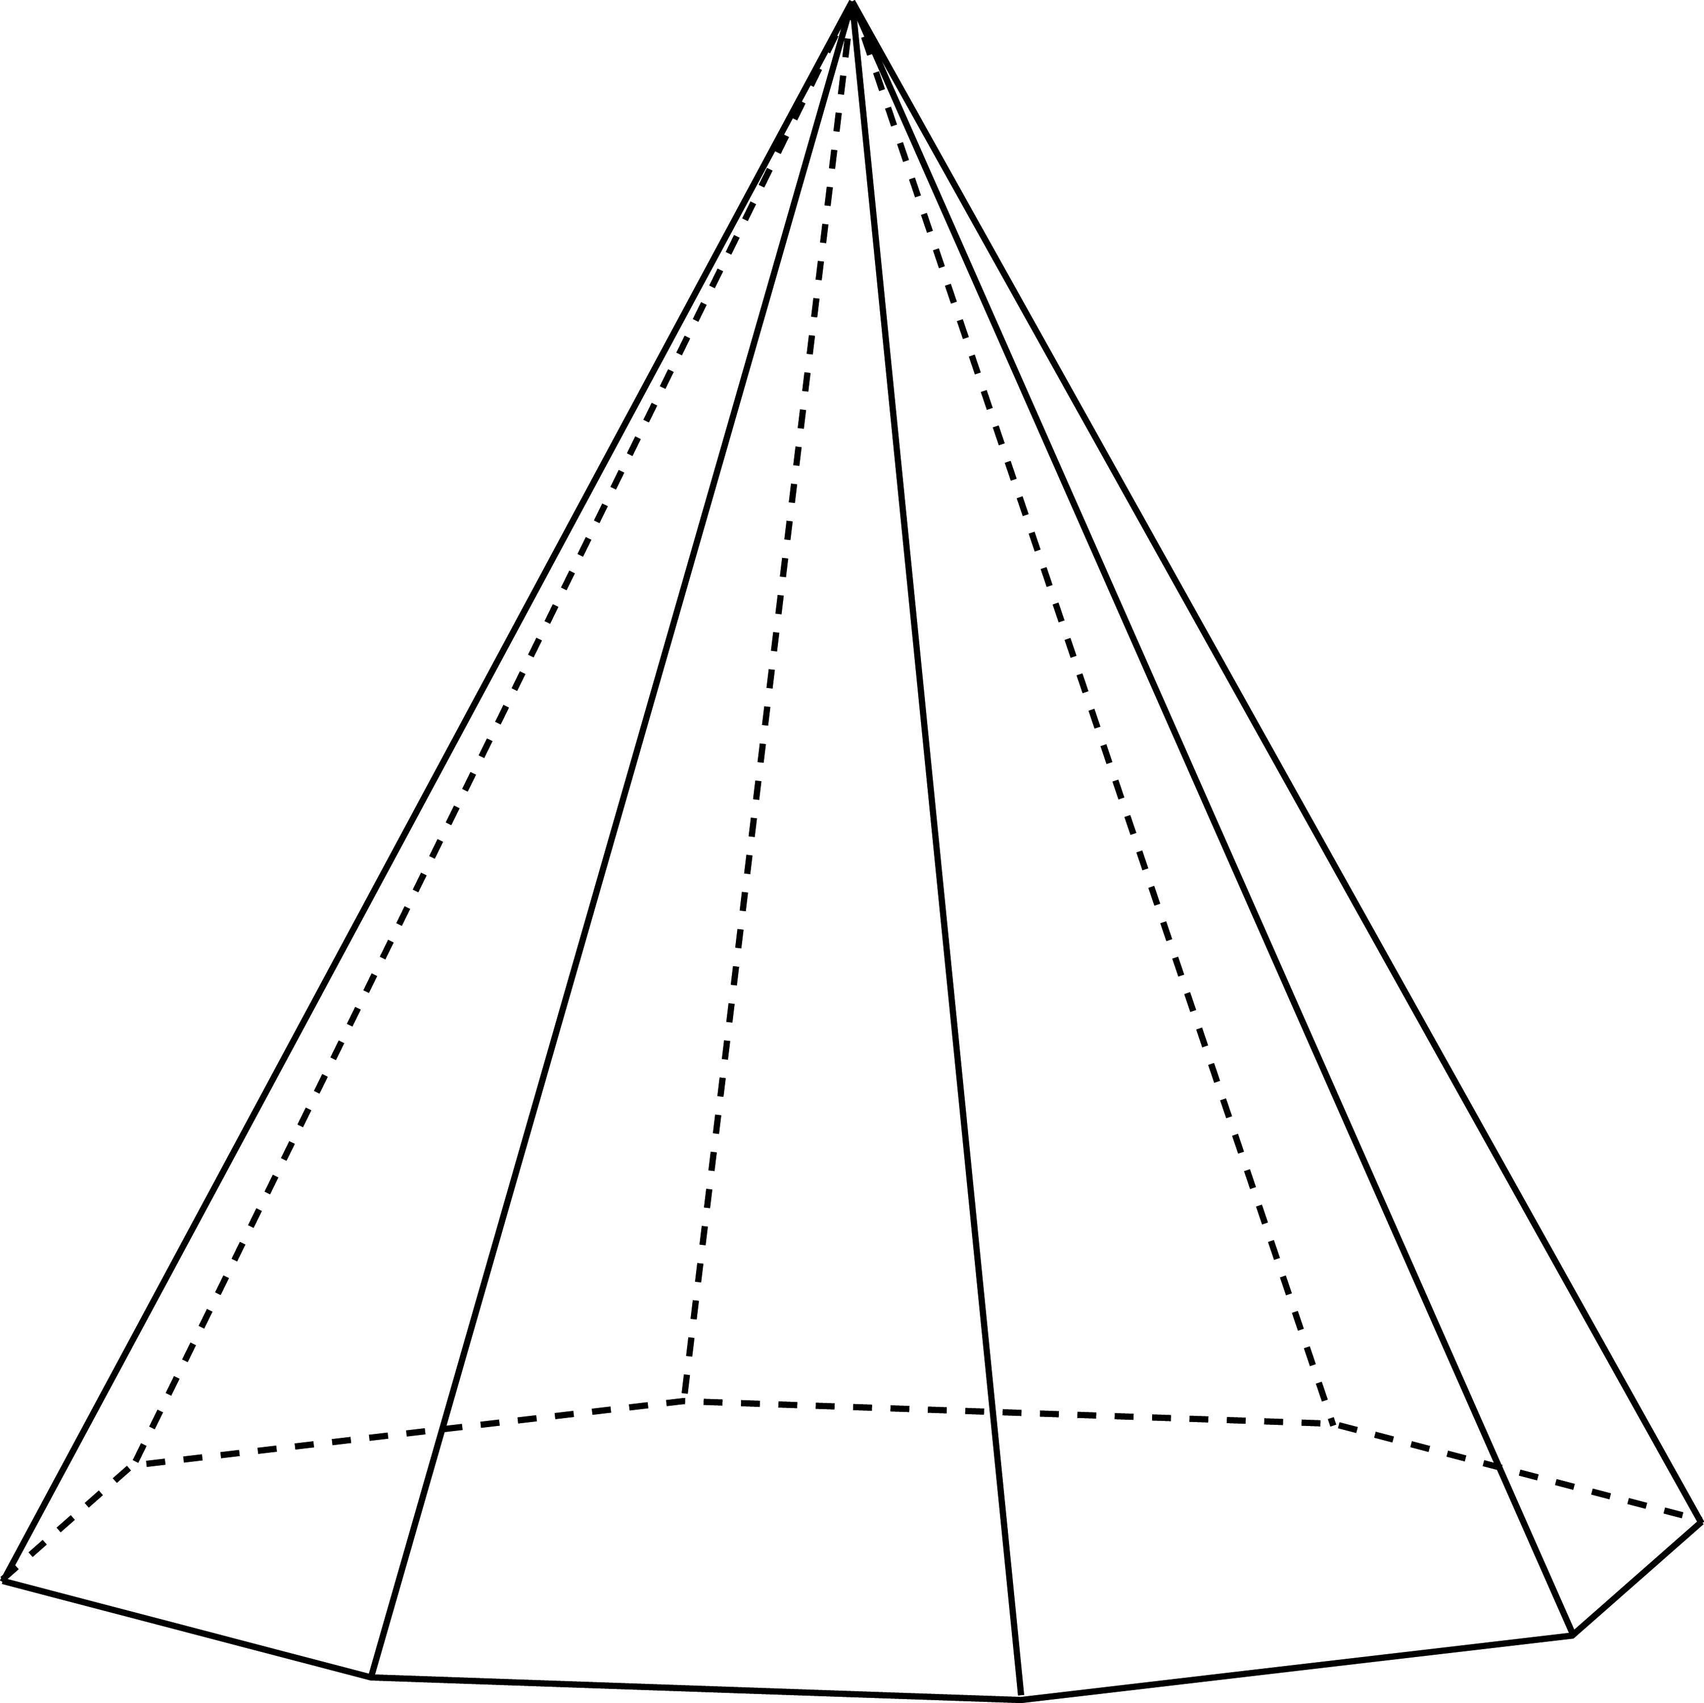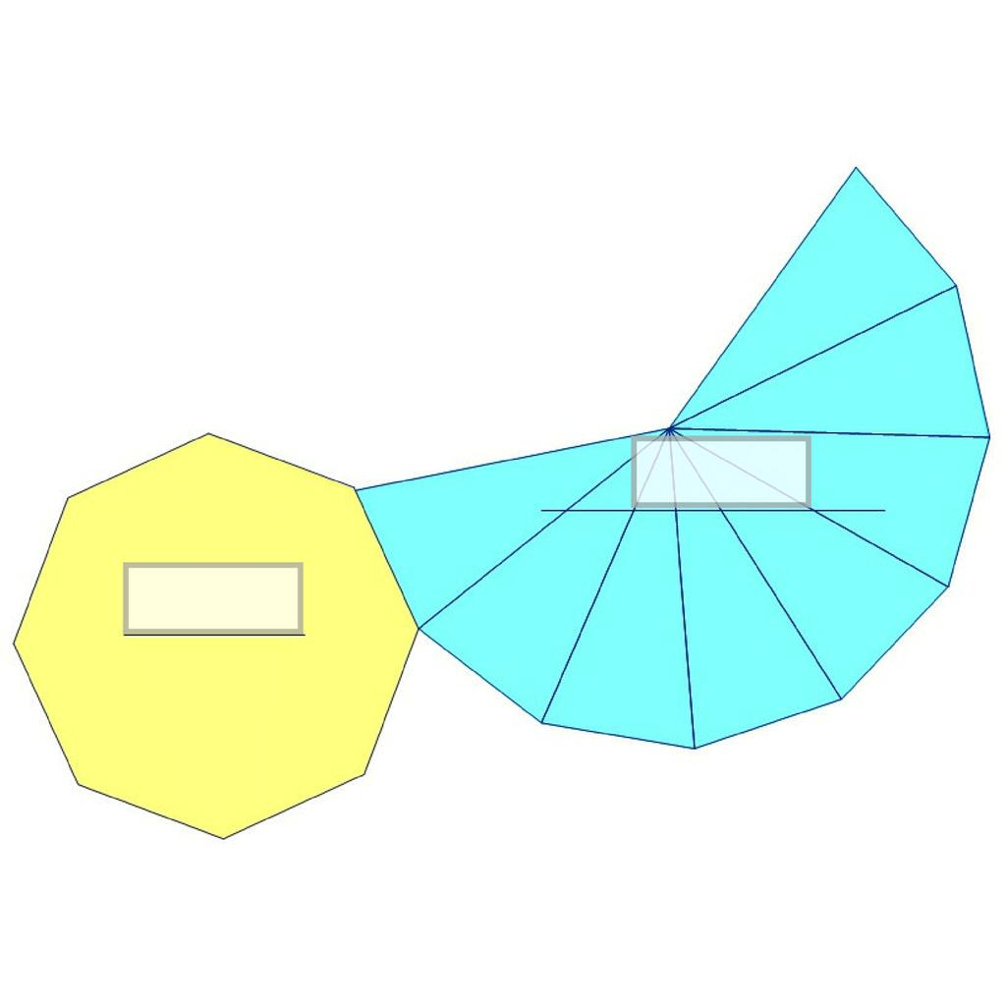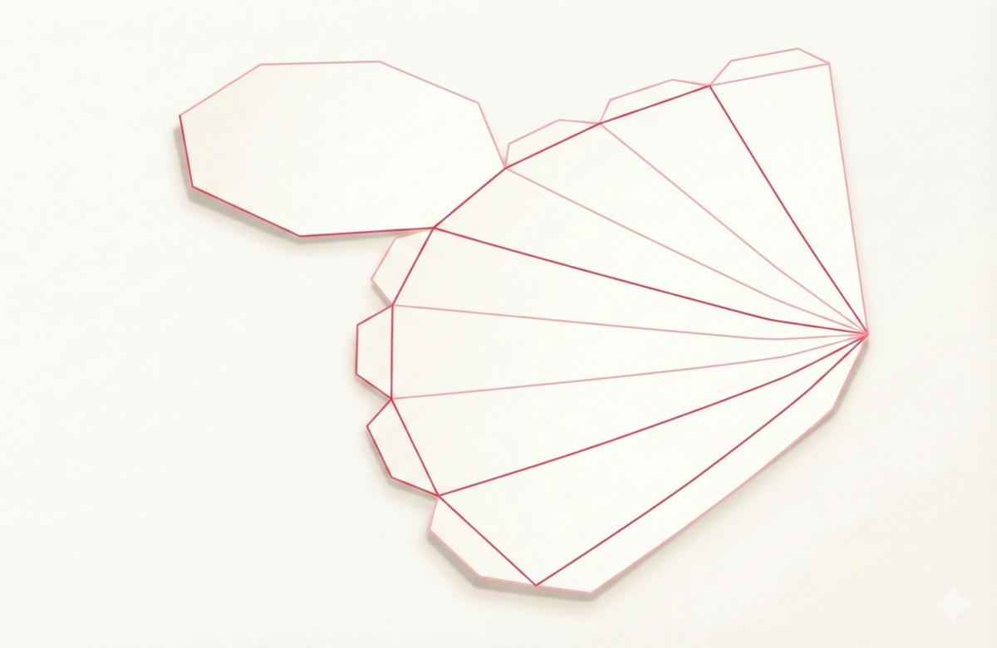

Definition
# Source: AI Source: Provided by: [Data Path: Persons Table -> ID Column: 1, Name_En Column: Motasem Essam] -> From: [ChatGPT] on [7/25/2026]
An Octagonal Pyramid is a three-dimensional geometric solid with an octagonal base (a polygon with eight sides) and eight triangular lateral faces that meet at a single common point called the apex.
The base can be a regular or irregular octagon. Depending on the position of the apex, the pyramid can be right or oblique.

Simple Definition
# Source: AI Source: Provided by: [Data Path: Persons Table -> ID Column: 1, Name_En Column: Motasem Essam] -> From: [ChatGPT] on [7/25/2026]
An Octagonal Pyramid is a solid with:
- One eight-sided polygon as its base.
- Eight triangular lateral faces.
- One apex where all eight triangular faces meet.

Classification Tree
# Source: AI Source: Provided by: [Data Path: Persons Table -> ID Column: 1, Name_En Column: Motasem Essam] -> From: [ChatGPT] on [7/25/2026]
Solid Geometry
└── Types of Solids
└── Pyramids
└── Types of Pyramids
└── Octagonal Pyramid
├── Regular Octagonal Pyramid
└── Irregular Octagonal Pyramid
According to the position of the apex:
- Right Octagonal Pyramid
- Oblique Octagonal Pyramid

Key Characteristics
# Source: AI Source: Provided by: [Data Path: Persons Table -> ID Column: 1, Name_En Column: Motasem Essam] -> From: [ChatGPT] on [7/25/2026]
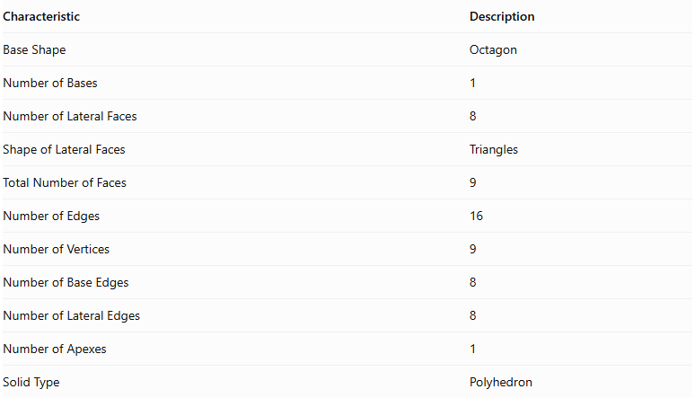
Characteristic | Description
Base Shape | Octagon
Number of Bases | 1
Number of Lateral Faces | 8
Shape of Lateral Faces | Triangles
Total Number of Faces | 9
Number of Edges | 16
Number of Vertices | 9
Number of Base Edges | 8
Number of Lateral Edges | 8
Number of Apexes | 1
Solid Type | Polyhedron

Regular Octagonal Pyramid
# Source: AI Source: Provided by: [Data Path: Persons Table -> ID Column: 1, Name_En Column: Motasem Essam] -> From: [ChatGPT] on [7/25/2026]
A Regular Octagonal Pyramid has a regular octagon as its base, with the apex directly above the center of the base in a right pyramid.
Its eight lateral faces are congruent isosceles triangles.

Geometric Representation
# Source: AI Source: Provided by: [Data Path: Persons Table -> ID Column: 1, Name_En Column: Motasem Essam] -> From: [ChatGPT] on [7/25/2026]
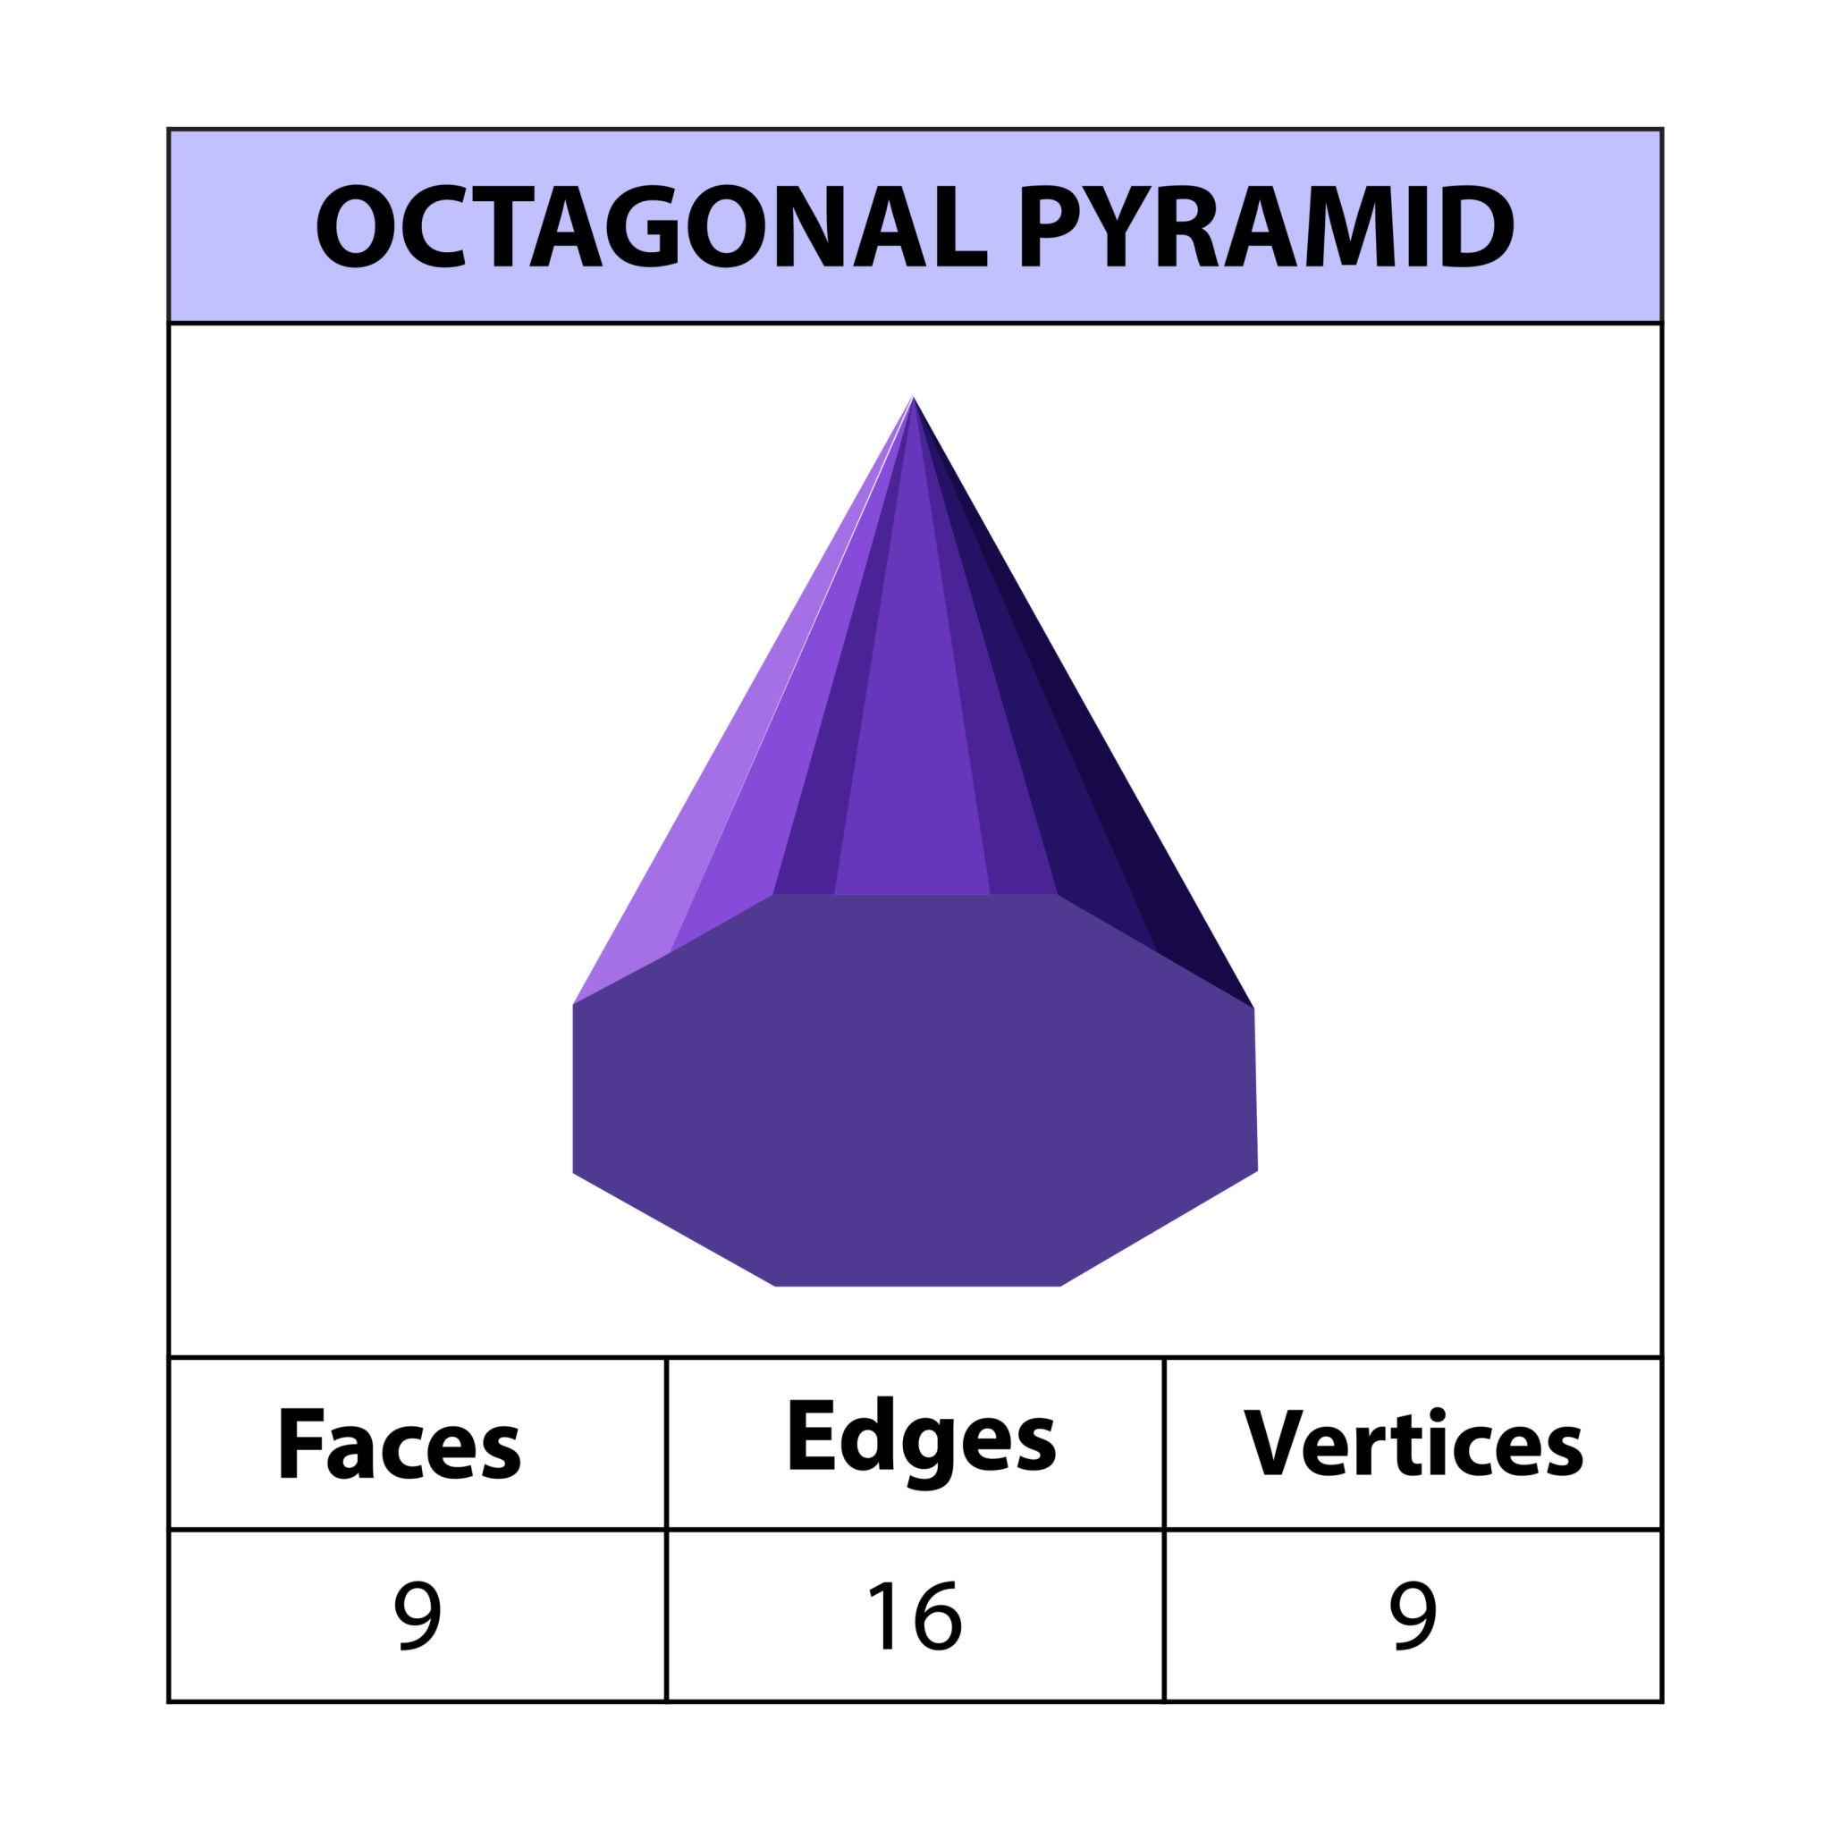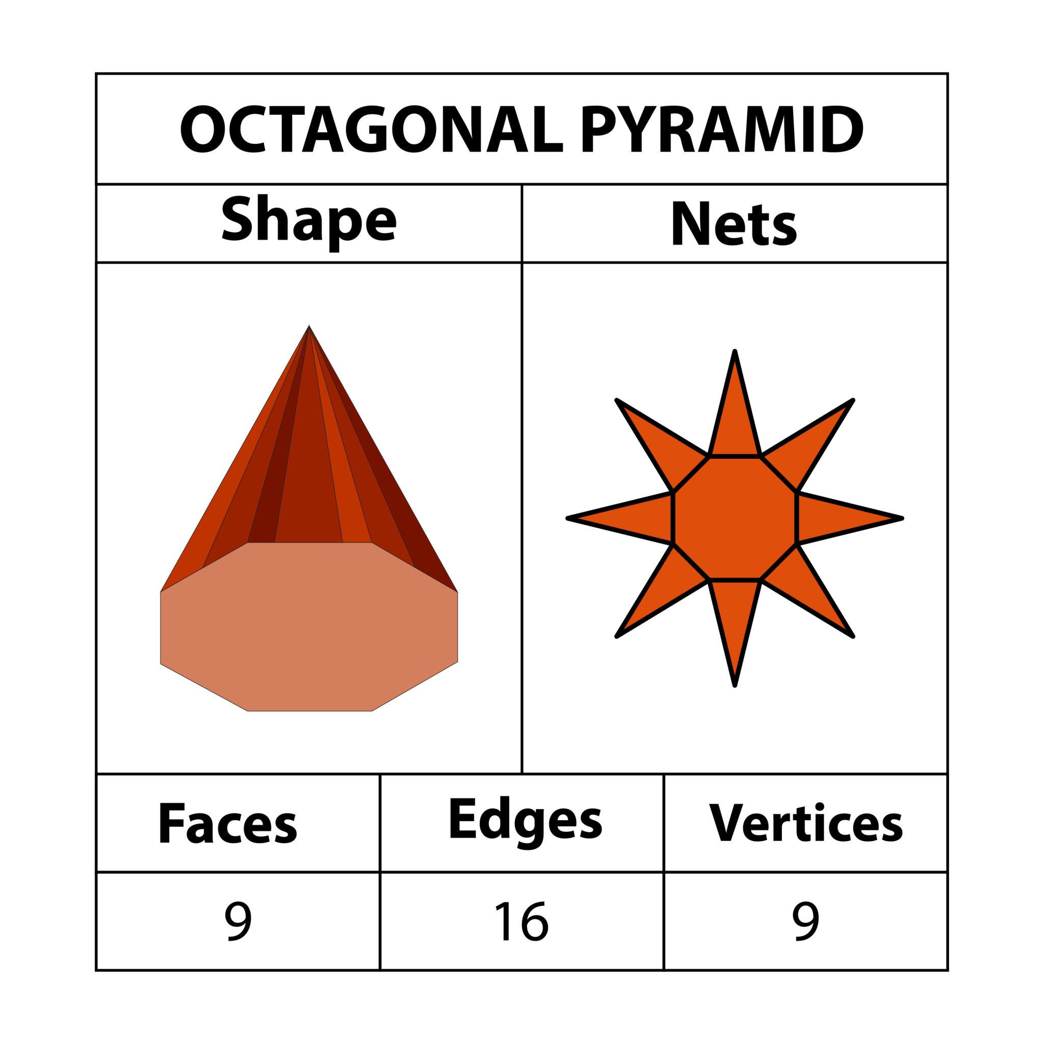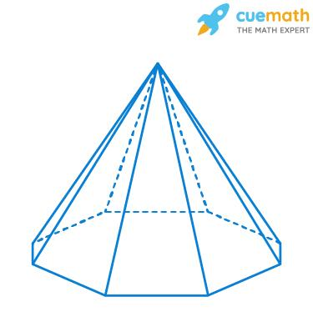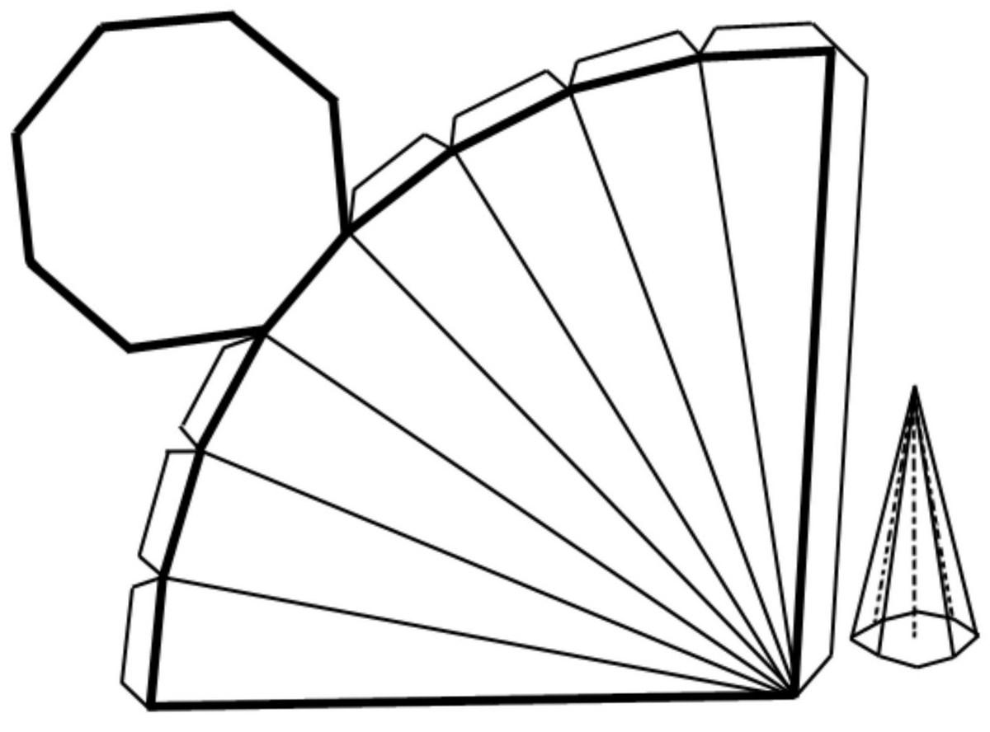

Main Components
# Source: AI Source: Provided by: [Data Path: Persons Table -> ID Column: 1, Name_En Column: Motasem Essam] -> From: [ChatGPT] on [7/25/2026]
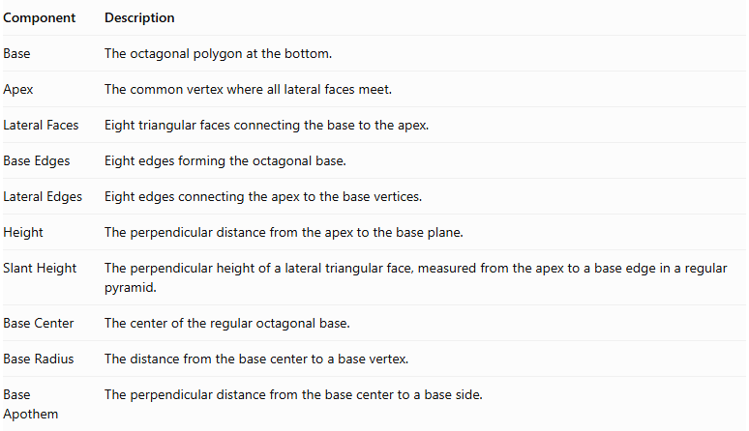
Component | Description
Base | The octagonal polygon at the bottom.
Apex | The common vertex where all lateral faces meet.
Lateral Faces | Eight triangular faces connecting the base to the apex.
Base Edges | Eight edges forming the octagonal base.
Lateral Edges | Eight edges connecting the apex to the base vertices.
Height | The perpendicular distance from the apex to the base plane.
Slant Height | The perpendicular height of a lateral triangular face, measured from the apex to a base edge in a regular pyramid.
Base Center | The center of the regular octagonal base.
Base Radius | The distance from the base center to a base vertex.
Base Apothem | The perpendicular distance from the base center to a base side.

Mathematical Representations and Formulas
# Source: AI Source: Provided by: [Data Path: Persons Table -> ID Column: 1, Name_En Column: Motasem Essam] -> From: [ChatGPT] on [7/25/2026]
Let:
- $a$ = side length of the regular octagonal base.
- $h$ = vertical height of the pyramid.
- $l$ = slant height of a lateral face.
- $r$ = apothem of the base.
- $R$ = circumradius of the base.
- $B$ = base area.
- $P$ = base perimeter.

A. Base Perimeter
# Source: AI Source: Provided by: [Data Path: Persons Table -> ID Column: 1, Name_En Column: Motasem Essam] -> From: [ChatGPT] on [7/25/2026]
For a regular octagon:
$$P=8a$$

B. Base Area
# Source: AI Source: Provided by: [Data Path: Persons Table -> ID Column: 1, Name_En Column: Motasem Essam] -> From: [ChatGPT] on [7/25/2026]
$$B=\frac{1}{2}Pr$$
$$B=4ar$$
Using the side length directly:
$$B=\frac{2a^{2}}{tan({22.5}^{∘})}$$

C. Base Apothem
# Source: AI Source: Provided by: [Data Path: Persons Table -> ID Column: 1, Name_En Column: Motasem Essam] -> From: [ChatGPT] on [7/25/2026]
$$r=\frac{a}{2tan({22.5}^{∘})}$$

D. Circumradius
# Source: AI Source: Provided by: [Data Path: Persons Table -> ID Column: 1, Name_En Column: Motasem Essam] -> From: [ChatGPT] on [7/25/2026]
$$R=\frac{a}{2sin({22.5}^{∘})}$$

E. Height and Slant Height
# Source: AI Source: Provided by: [Data Path: Persons Table -> ID Column: 1, Name_En Column: Motasem Essam] -> From: [ChatGPT] on [7/25/2026]
For a regular right octagonal pyramid:
$$l=\sqrt{h^{2}+r^{2}}$$

F. Lateral Surface Area
# Source: AI Source: Provided by: [Data Path: Persons Table -> ID Column: 1, Name_En Column: Motasem Essam] -> From: [ChatGPT] on [7/25/2026]
The lateral surface consists of eight congruent triangular faces.
$$LSA=\frac{1}{2}Pl$$
$$LSA=4al$$

G. Total Surface Area
# Source: AI Source: Provided by: [Data Path: Persons Table -> ID Column: 1, Name_En Column: Motasem Essam] -> From: [ChatGPT] on [7/25/2026]
$$TSA=B+LSA$$
$$TSA=4ar+4al$$

H. Volume
# Source: AI Source: Provided by: [Data Path: Persons Table -> ID Column: 1, Name_En Column: Motasem Essam] -> From: [ChatGPT] on [7/25/2026]
$$V=\frac{1}{3}Bh$$
$$V=\frac{4arh}{3}$$

I. Number of Faces, Edges, and Vertices
# Source: AI Source: Provided by: [Data Path: Persons Table -> ID Column: 1, Name_En Column: Motasem Essam] -> From: [ChatGPT] on [7/25/2026]
For a pyramid with an $n$-sided base:
$$F=n+1$$
$$E=2n$$
$$V=n+1$$
For an Octagonal Pyramid, $n=8$:
- Faces = 9
- Edges = 16
- Vertices = 9

Worked Examples

Example 1: Calculate the Number of Faces, Edges, and Vertices
# Source: AI Source: Provided by: [Data Path: Persons Table -> ID Column: 1, Name_En Column: Motasem Essam] -> From: [ChatGPT] on [7/25/2026]
Given:
$$n=8$$
Faces:
$$F=8+1=\boxed{9}$$
Edges:
$$E=2(8)=\boxed{16}$$
Vertices:
$$V=8+1=\boxed{9}$$

Example 2: Calculate the Base Perimeter
# Source: AI Source: Provided by: [Data Path: Persons Table -> ID Column: 1, Name_En Column: Motasem Essam] -> From: [ChatGPT] on [7/25/2026]
Given:
$$a=5 cm$$
$$P=8(5)$$
$$\boxed{P=40 cm}$$

Example 3: Calculate the Base Area
# Source: AI Source: Provided by: [Data Path: Persons Table -> ID Column: 1, Name_En Column: Motasem Essam] -> From: [ChatGPT] on [7/25/2026]
Given a regular octagonal base with:
$$a=4 cm$$
$$B=\frac{2(4)^{2}}{tan({22.5}^{∘})}$$
$$\boxed{B≈77.25{ cm}^{2}}$$

Example 4: Calculate the Volume
# Source: AI Source: Provided by: [Data Path: Persons Table -> ID Column: 1, Name_En Column: Motasem Essam] -> From: [ChatGPT] on [7/25/2026]
Given:
$$B=77.25{ cm}^{2}$$
$$h=12 cm$$
$$V=\frac{1}{3}(77.25)(12)$$
$$\boxed{V=309{ cm}^{3}}$$

Example 5: Calculate the Lateral and Total Surface Areas
# Source: AI Source: Provided by: [Data Path: Persons Table -> ID Column: 1, Name_En Column: Motasem Essam] -> From: [ChatGPT] on [7/25/2026]
Given:
$$a=4 cm, l=8 cm$$
Perimeter:
$$P=8(4)=32 cm$$
Lateral surface area:
$$LSA=\frac{1}{2}(32)(8)$$
$$\boxed{LSA=128{ cm}^{2}}$$
Total surface area:
$$TSA=77.25+128$$
$$\boxed{TSA≈205.25{ cm}^{2}}$$

Comparison with Related Pyramids
# Source: AI Source: Provided by: [Data Path: Persons Table -> ID Column: 1, Name_En Column: Motasem Essam] -> From: [ChatGPT] on [7/25/2026]
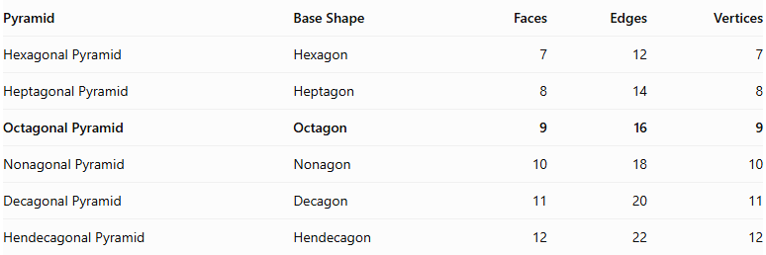
Pyramid | Base Shape | Faces | Edges | Vertices
Hexagonal Pyramid | Hexagon | 7 | 12 | 7
Heptagonal Pyramid | Heptagon | 8 | 14 | 8
Octagonal Pyramid | Octagon | 9 | 16 | 9
Nonagonal Pyramid | Nonagon | 10 | 18 | 10
Decagonal Pyramid | Decagon | 11 | 20 | 11
Hendecagonal Pyramid | Hendecagon | 12 | 22 | 12

Constructing Octagonal Pyramid in Solid Geometry

Instruments Used
# Source: AI Source: Provided by: [Data Path: Persons Table -> ID Column: 1, Name_En Column: Motasem Essam] -> From: [ChatGPT] on [7/25/2026]
The construction uses physical geometric drawing instruments rather than coordinate-based methods.
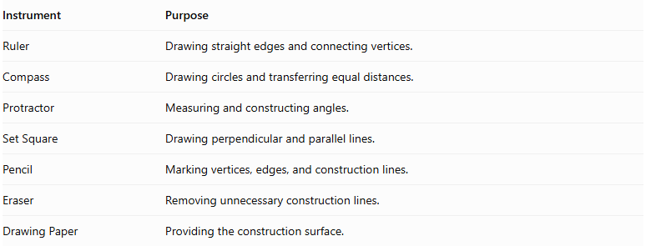
Instrument | Purpose
Ruler | Drawing straight edges and connecting vertices.
Compass | Drawing circles and transferring equal distances.
Protractor | Measuring and constructing angles.
Set Square | Drawing perpendicular and parallel lines.
Pencil | Marking vertices, edges, and construction lines.
Eraser | Removing unnecessary construction lines.
Drawing Paper | Providing the construction surface.

Construction Procedures

Base-Based Construction
# Source: AI Source: Provided by: [Data Path: Persons Table -> ID Column: 1, Name_En Column: Motasem Essam] -> From: [ChatGPT] on [7/25/2026]
- Draw an octagonal base using a ruler, compass, and protractor.
- Identify and mark its eight vertices.
- Determine the position of the apex above or away from the base.
- Connect the apex to each of the eight base vertices.
- Complete the eight triangular lateral faces.
- Darken the visible edges and use dashed lines for hidden edges.

Apex-Based Construction
# Source: AI Source: Provided by: [Data Path: Persons Table -> ID Column: 1, Name_En Column: Motasem Essam] -> From: [ChatGPT] on [7/25/2026]
- Mark the intended apex position.
- Draw the octagonal base beneath the apex.
- Identify the eight base vertices.
- Connect each base vertex to the apex.
- Complete the lateral triangular faces.

Vertex-Connection Construction
# Source: AI Source: Provided by: [Data Path: Persons Table -> ID Column: 1, Name_En Column: Motasem Essam] -> From: [ChatGPT] on [7/25/2026]
- Construct the eight vertices of the octagonal base.
- Mark the apex as the ninth vertex.
- Connect the apex to all eight base vertices.
- Connect consecutive base vertices to complete the octagonal base.
- Check that all edges and faces form a closed solid.

Edge-Based Construction
# Source: AI Source: Provided by: [Data Path: Persons Table -> ID Column: 1, Name_En Column: Motasem Essam] -> From: [ChatGPT] on [7/25/2026]
- Draw the eight edges of the octagonal base.
- Determine the eight lateral edges extending from the base vertices to the apex.
- Construct and connect the lateral edges.
- Complete the triangular lateral faces.

Face-Based Construction
# Source: AI Source: Provided by: [Data Path: Persons Table -> ID Column: 1, Name_En Column: Motasem Essam] -> From: [ChatGPT] on [7/25/2026]
- Construct the octagonal base.
- Draw eight triangular faces around the base.
- Connect the corresponding vertices and edges.
- Ensure that all eight triangular faces meet at the apex.

Net-Based Construction
# Source: AI Source: Provided by: [Data Path: Persons Table -> ID Column: 1, Name_En Column: Motasem Essam] -> From: [ChatGPT] on [7/25/2026]
- Draw one octagonal base.
- Construct eight triangular faces around the octagon.
- Add tabs if necessary for physical assembly.
- Cut out the net.
- Fold the triangular faces upward.
- Join their edges to form the octagonal pyramid.
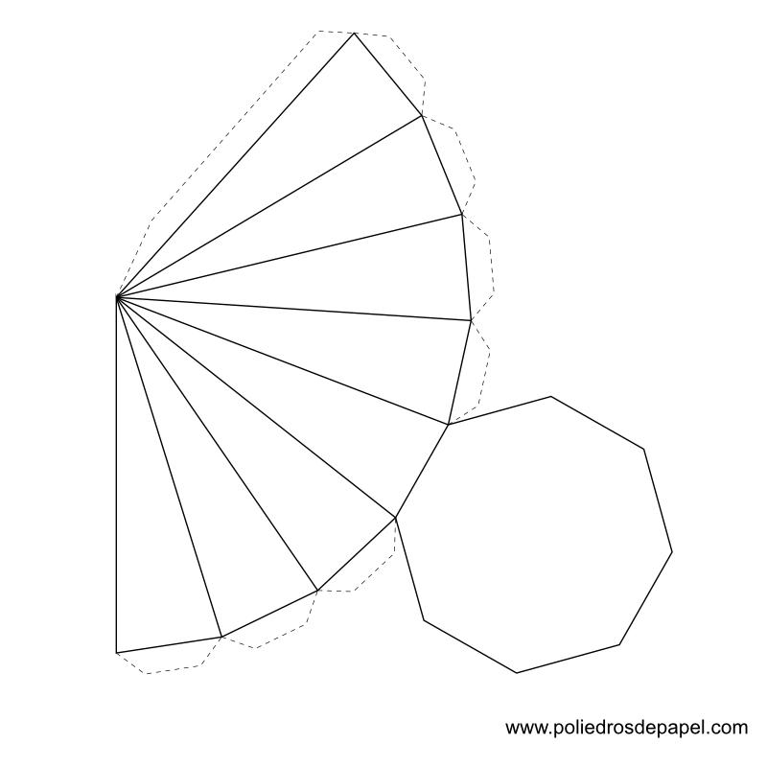

Applications
# Source: AI Source: Provided by: [Data Path: Persons Table -> ID Column: 1, Name_En Column: Motasem Essam] -> From: [ChatGPT] on [7/25/2026]
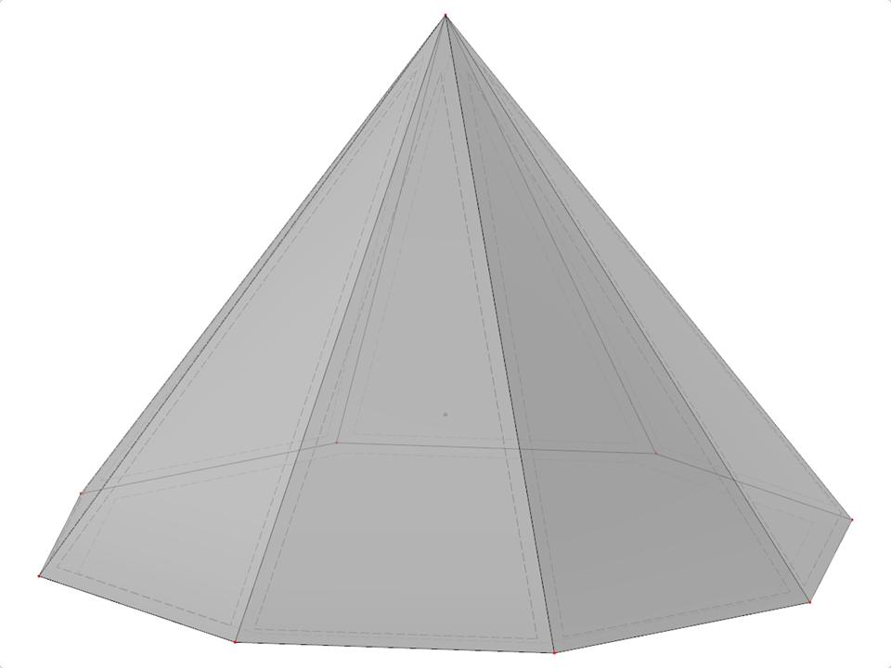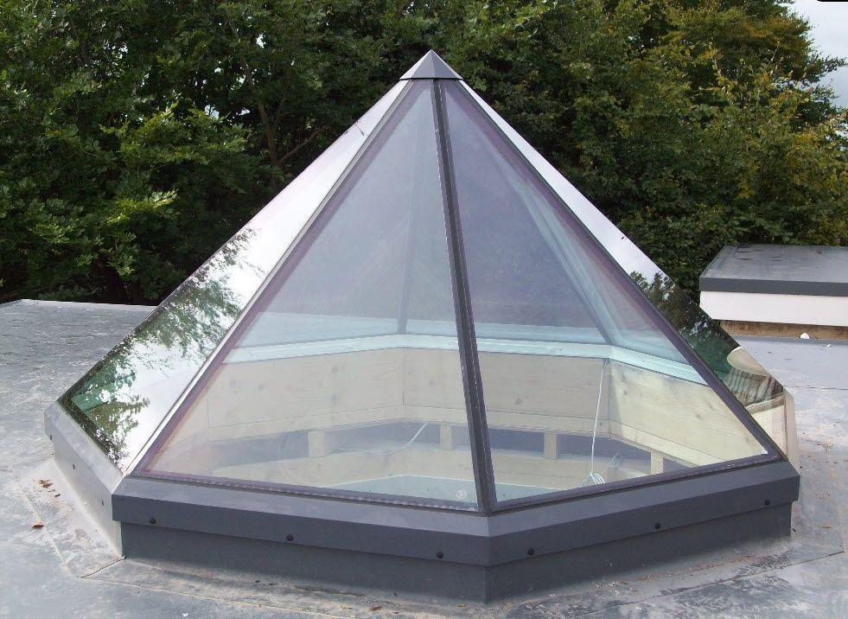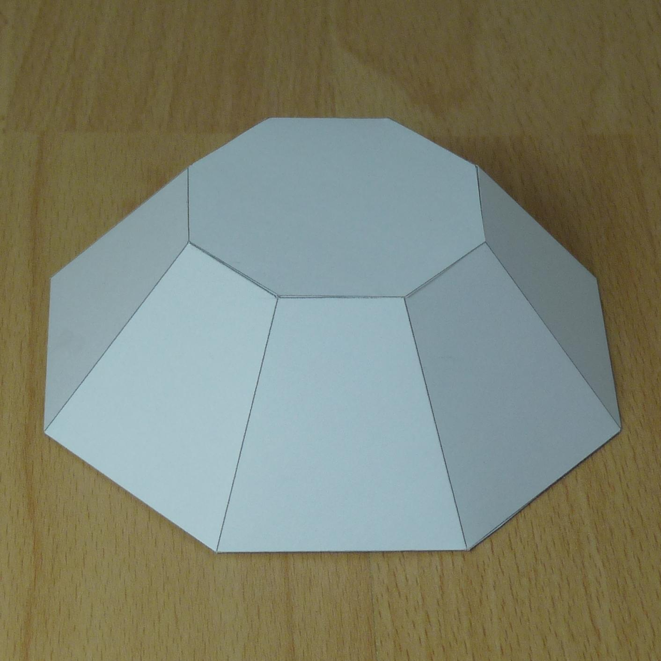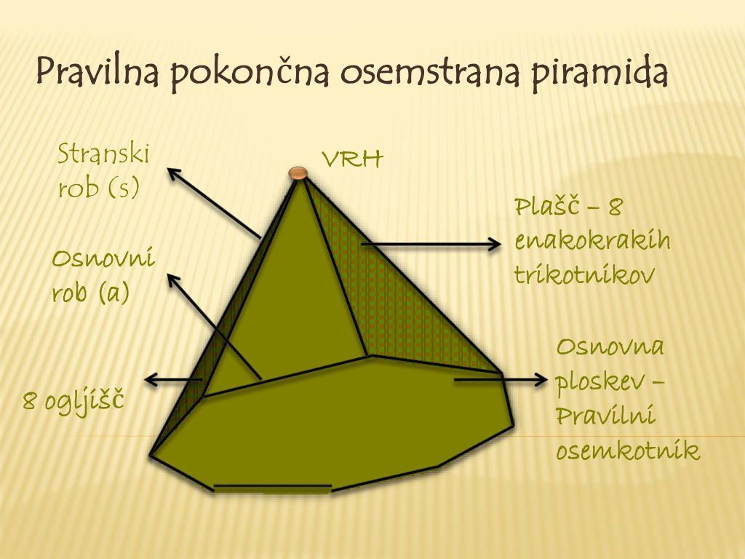
- Architecture: Decorative roofs and architectural structures with octagonal bases.
- Mathematical Models: Teaching polygonal pyramids and three-dimensional geometry.
- Sculpture: Geometric sculptures and decorative objects.
- Engineering: Studying triangular face arrangements and structural geometry.

Key Points
# Source: AI Source: Provided by: [Data Path: Persons Table -> ID Column: 1, Name_En Column: Motasem Essam] -> From: [ChatGPT] on [7/25/2026]
- An Octagonal Pyramid has one octagonal base.
- It has eight triangular lateral faces.
- All eight lateral faces meet at one apex.
- It has 9 faces, 16 edges, and 9 vertices.
- Its volume is one-third of the product of its base area and perpendicular height.
- A regular right Octagonal Pyramid has a regular octagonal base and eight congruent isosceles triangular lateral faces.

Conclusion
# Source: AI Source: Provided by: [Data Path: Persons Table -> ID Column: 1, Name_En Column: Motasem Essam] -> From: [ChatGPT] on [7/25/2026]
An Octagonal Pyramid is a polyhedron characterized by an eight-sided polygonal base and eight triangular lateral faces meeting at a single apex. It has 9 faces, 16 edges, and 9 vertices, making it an important member of the polygonal pyramid family.

